MEET YOUR ATHLETIC TRAINERS
As part of their participation in Gainesville High School Athletics, each of our student athletes has access to a certified athletic trainer who is on-site each day and is present at most home events. Our athletic trainers and team physician’s dedication to our student-athletes, the coaches and the high schools is second to none. Their attention to detail is admirable and their ability to build trusting relationships with the student-athletes is comforting.
Our athletic trainers are provided through the University of Florida and the UF Health Orthopedics and Sports Medicine Institute. Each athletic trainer is board certified and licensed by the state of Florida.
Injuries are an unwelcome part of the game that comes without warning and often causes great mental and physical anguish. Although we cannot totally prevent injuries, we are relieved to say that we can and do offer the very best post injury treatment available for our student-athletes. Key areas of emphasis include:
- Injury Prevention
- Clinical Evaluation and Injury Assessment
- Rehabilitation
- Referral of injured athletes to additional medical professionals when appropriate
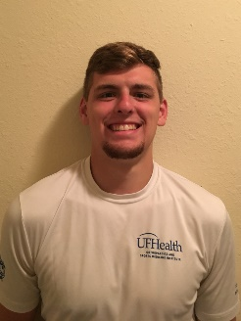
Treven Gezella LAT, ATC

Graduate Assistant Athletic Trainer

Treven was a student athletic training intern for ESPN Wide World of Sports at Disney World in Orlando, FL during the summer of 2016. Treven received his bachelor’s degree in Athletic Training from Northern Michigan University in 2017. He is currently a Graduate Assistant Athletic Trainer with UF Health while also pursuing his master’s degree in Applied Physiology and Kinesiology at the University of Florida. Treven currently serves as the head athletic trainer at Gainesville High School. He is certified by the National Athletic Trainers Association Board of Certification and licensed by the State of Florida.
Cassie Winkfield, MS, LAT, ATC, OTC
UF Health Department of Orthopedics Sports Medicine
Staff Athletic Trainer

Cassie serves as an athletic trainer for the University of Florida Physicians, primarily working with two orthopedic surgeons. In addition to her clinical work, Cassie serves as a mentor to the high school graduate assistant athletic trainers at Buchholz HS, Gainesville HS, Fort White HS, and Santa Fe HS.
Cassie earned her Bachelor of Arts in Athletic Training from University of Northern Iowa in 2008. Cassie then completed a year internship at Charleston Southern University as an assistant athletic trainer with the football and softball teams. While at CSU she was awarded the Southeast Athletic Trainers Association Collegiate Athletic Training staff of the year. In 2011, she earned her Masters of Science from the University of Kentucky, and served as a graduate assistant at Madison Central High School. Following graduation, she continued to work as head athletic trainer at Madison Central High School for 4 years before starting her current position.
Cassie is a member of the Athletic Training Association of Florida, and serves on the Committee on Practice Advancement. She is also a member of Southeast Athletic Trainers’ Association, and National Athletic Trainers Association. She currently serves at the National level as the liaison for the National Association of Orthopedic Technologists (NAOT). In addition to her Florida and national athletic training certifications and licensures, she is certified by the NAOT as an orthopedic technologist.
Meet Your Team Physicians
Seth Smith, M.D., CAQSM, PharmD

Assistant Professor
Co-Medical Director High School Outreach Program
Primary Care Sports Medicine, ORTHOcare
Team Physician:

Michael Seth Smith, M.D., earned his medical degree at Florida State University in 2008 before going on to complete his residency in Community Health and Family Medicine at the University of Florida and his fellowship in Primary Care Sports Medicine at the University of Florida. Smith also obtained a Doctorate of Pharmacy and at UF in 2002.
He came to the Department of Orthopaedics at UF in 2011 to join the Division of Sports Medicine. Smith has various certifications, including Basic Life Support, Advanced Cardiovascular Life Support, Advanced Trauma Life Support, and Pediatric Advanced Life Support. He is the current Co Medical Director of Adolescent and High School Outreach Program and is the head team physician for Santa Fe College athletic department, Gainesville High School, and Santa Fe High School.
Smith is a member of the American College of Sports Medicine and the American Medical Society of Sports Medicine. He was awarded the Golden Apple Teaching Award and the Society of Teachers of Family Medicine - Resident Teacher of the Year in 2011.

Eddie Haupt, MD
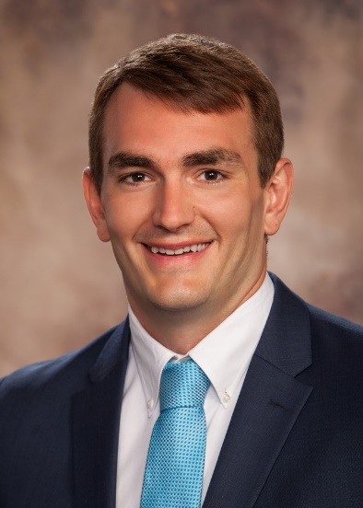
Eddie earned his undergraduate degree and medical degree from the University of Florida. He is currently pursuing his orthopedic surgery residency at UF and will graduate in 2020.
After graduating residency, Eddie will be pursuing a fellowship subspecialty training in sports medicine and foot/ankle reconstruction
Eddie is a former UF football player. He played from 2005-09 where he was a 2 time SEC/national champ and an academic all-American.

